Metamora’s Spring Clean-Up Day
Saturday, May 11th, 2024
8 a.m. to Noon @ 730 W. Dryden Road
Metamora Township Hall
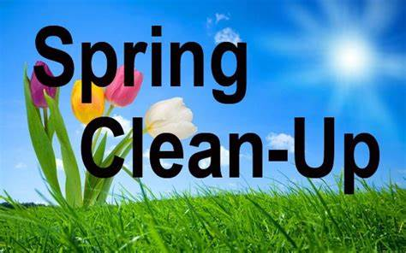
JIM’S RECYCLING, XTREME SHREDS & RICK RHEIN WILL HAVE DUMPSTERS, A SHREDDING MACHINE, & TRASH COMPACTORS FOR THIS EVENT.
THIS IS A FREE SERVICE FOR
METAMORA VILLAGE AND TOWNSHIP RESIDENTS ONLY.
This service is only offered once a year.
Please take advantage of this FREE opportunity and help keep Metamora trash free.
TRASH GUIDELINES:
- Residents must be able to unload items yourself.
- Only Dried out/empty paint cans are accepted. No hazardous materials will be accepted.
- Batteries are accepted.
- Metamora Businesses limited to 5 Boxes of shredding
Metamora Township received a SCRAP TIRE CLEANUP GRANT from EGLE allowing Metamora Township residents to bring an UNLIMITED number of tires for this year ONLY.
If you have any questions concerning this clean-up, please call the Township Hall @ 810-678-2237, Monday thru Thursday, 9:00 a.m. to 5:00 p.m. and we will be happy to answer any questions you may have.
See you on May 11th, 2024

